ESTMINSTER SCHOOL HAS NEW BOUNDARIES FALL 2021

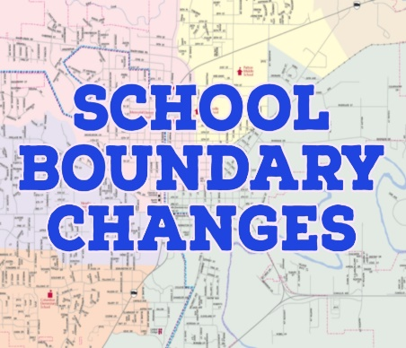
What The New Boundary Changes Mean To You
- Check out all school boundaries for Lethbridge School Division at Board passes motion to change school boundaries for 2021/2022 | Lethbridge School Division (lethsd.ab.ca) (North side school boundaries attached).
- Determine your boundary elementary school
- You will be automatically pre-enrolled in your new boundary school

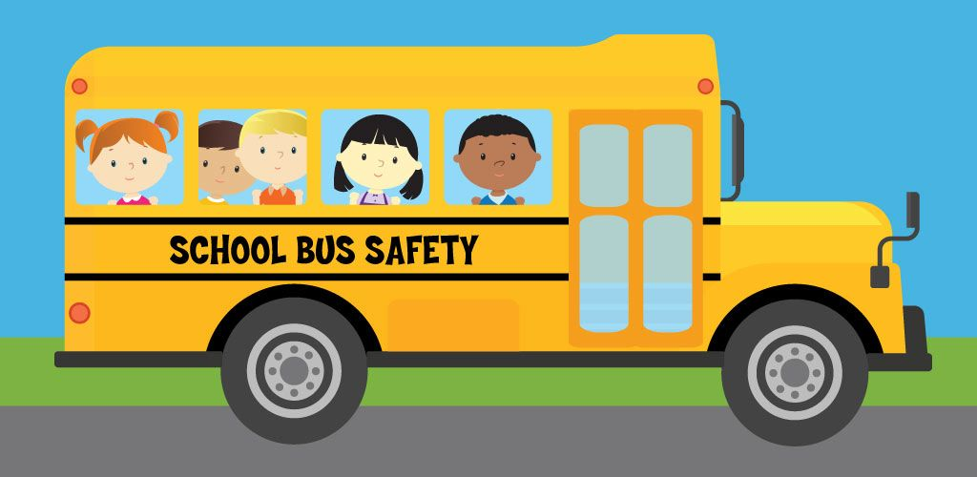
Bussing Will Be Provided to Eligible Families
- Families living south of 5th Ave N and West of 13th Street north will be eligible for bussing.
- Families living East of 23rd Street (Mayor Magrath North) and north of 7th Ave will be eligible for bussing.
- Letters have been sent to families. They can sign up for transportation later in the spring.
- Bussing is not available for Out of Boundary students.
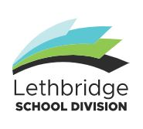
Lethbridge School Division Has A School Choice Policy
- Policy 501.3.1 allows for consideration of requests for students to attend school outside of their boundary area.
- If you would like to attend any school as an out of boundary student you need to complete the Out Of Boundary Form by March 23, 2021. This allows you to be considered for registration in an out of boundary school.
        - The form can be found on the Westminster School Webpage as a side button. It can also be found on the division website at https://www.lethsd.ab.ca/download/332444.
        - The form is submitted by e-mail to leeanne.tedder@lethsd.ab.ca
        - Families will be notified if Out Of Boundary enrollment is possible in April
For More Information About Westminster’s New Boundaries please refer to the following:
Superintendents Letter to Families (mailed directly to families): February 26, 2021
School Choice Policy on the Lethbridge School Division Website: LETHBRIDGE SCHOOL DISTRICT NO (lethsd.ab.ca)

