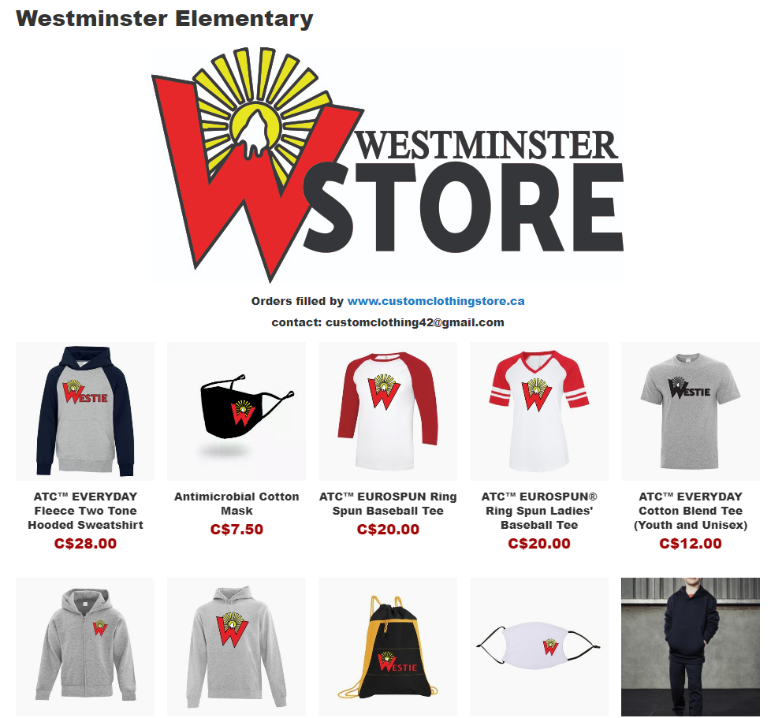

Check out the Westminster online clothing store. Enjoy customizing your Westminster swag with the approved logos and graphics. Orders take 2-3 weeks for delivery to your home. Click the image to start shopping.

