Westminster Elementary School

2024/25 Annual Education Results Report

School Vision Statement

The purpose of education is to provide the necessary skills to develop productive Canadian Citizens. Our vision is to increase necessary skills to develop productive Canadian Citizens. Our vision is to increase student, parent, and community engagement to promote excellence in achievement.

School Mission Statement

* We believe that students and learning come first.
* We believe all our students can learn.
* We believe positive teacher-student and student-student relationships create learning environments that help students become respectful, caring, and responsible citizens.
* We believe that exemplary teaching is linked to excellence in learning.
* We believe that out-of-classroom contributions enhance our school and community.
* We believe that our Dream School concept positively impacts and enhances student experiences.



Westminster School, nestled in the heart of the city, provides a dynamic and supportive environment where children are empowered to succeed in diverse ways. Our students embody the core values of the Circle of Courage—Try, Give, Choose, and Belong—which guide their personal and academic development.

At Westminster, we are committed to going the extra mile for our students, offering rigorous academic programs while promoting well-being through a wide range of arts and athletic opportunities. Our core philosophy, “It takes a village to raise a child,” is reflected in our strong partnerships with families and the broader community, ensuring that every child’s unique learning needs are met.

With a small student population, we are able to foster meaningful, one-on-one relationships, creating an environment where each child’s potential is recognized and nurtured. Our classrooms are vibrant, multi-age learning spaces where students engage in rich, hands-on experiences. In addition to a robust academic curriculum, we offer a variety of enrichment activities, field trips, fine arts programs, and daily breakfast to support the holistic development of every child.

The active involvement of our School Council and dedicated community partners plays a vital role in making Westminster an even better place to learn and grow. Together, we create a strong foundation for students to thrive both academically and personally.

[**www.west.lethsd.ab.ca**](http://www.west.lethsd.ab.ca)

x

**Alberta Education Assurance Measures Overall Summary**

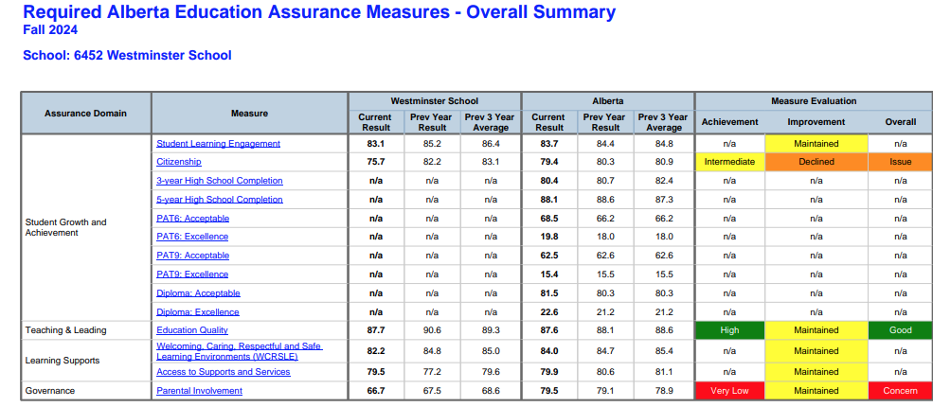

**Areas of success**

* Westminster shows strengths in education quality and program diversity
* Students have access to the right supports and services.
* Partnerships between school and home ensure that students receive necessary help for success.
* Strong School Council that supports the staff, community and students at Westminster.
* Students are motivated and are active participants in their learning.
* Strong numeracy and literacy instruction that is reflected in Provincial data that shows improvement and success with teaching strategies.

**Areas for growth**

* Focus is needed on improving parental involvement, and lifelong learning skills.
* Developing strategies to enhance citizenship education, and teacher professional development
* Continue monitoring and addressing areas of decline to ensure overall improvement.
* Use date to inform school planning and drive targeted enhancements in education
* Working on a growth mindset perspective with regards to the Westminster students.

Assurance Measure: Citizenship

Teacher, parent and student agreement that students model the characteristics of active citizenship

## Evaluation

## **1.Positive Student Perception** There was a significant increase in students feeling that citizenship has improved within the school. This indicates that students perceive their peers as effectively modeling the principles of the Circle of Courage character education program.

## **2.Impact of Previous Year's Efforts** The commitment and work dedicated to this initiative last year has shown positive results among the student body. This progress demonstrates the effectiveness of focused character education efforts.

## **3.Teacher Perspective and Ongoing Challenges** Despite student perceptions, teachers feel that students are not consistently demonstrating active citizenship. This discrepancy highlights the need for continued work in this area.

## **4. Future Focus Areas** Moving forward, additional emphasis should be placed on:

## Encouraging students to take on more leadership roles within the school

## Promoting increased student involvement in community activities

## **Conclusion** While progress has been made, there is still room for improvement in fostering active citizenship among students. Bridging the gap between student perceptions and teacher observations will be crucial for continued growth in this area.

**DOMAIN: STUDENT GROWTH AND ACHIEVEMENT**

Assurance Measure: Student Learning Engagement

Teacher, parent and student agreement that students are engaged in their learning at school.

## Evaluation

## Student Involvement Students are demonstrating increased involvement and interest in their education

## This engagement is crucial for their academic success and personal growth.

## Learning Commons Evolution There is a continued focus on transforming the Learning Commons into a more flexible learning space. This evolution will provide students with opportunities to engage in curriculum-based learning that requires critical thinking skills in collaboration with their peers.

## The evolving Learning Commons will include:

## Flexible seating arrangements

## Collaborative work areas

## Access to digital resources

## Makerspace for hands-on learning

## STEM Support A grant from the Sunrise Rotary will support the purchase of STEM materials, enhancing students' learning experiences in science, technology, engineering, and mathematics

## Teacher Collaboration Built-in collaborative time will be incorporated this year, allowing teachers to create engaging learning opportunities for students. This dedicated time will foster innovation and improve instructional practices.

## **5.** Literacy and Numeracy Focus A continued emphasis on literacy and numeracy best practices will be maintained

## This focus ensures students develop strong foundational skills essential for academic success across all subjects.

**DOMAIN: TEACHING AND LEADING**

Assurance Measure: Education Quality

Teacher, parent and student satisfaction with the overall quality of basic education.

## Evaluation

## **1**.Students and parents

## Students feel they are receiving a high-quality education.

## **2**.Teacher Concerns

## Teachers express concerns about their ability to provide the quality of education they aspire to deliver.

## **3**.Parent Concerns

## Parents expressed concern with the quality of education in respects to the receiving. (Do they understand the difference between teaching and receiving) How do we share it . Parents think the curriculum is not interesting.

## **4**.Curriculum Implementation

## It is crucial to ensure teachers have a thorough understanding of the new curriculum and how to create quality learning opportunities that engage students effectively.

## **5.**Outcome-Based Report Card Pilot

## Teachers are piloting an outcome-based report card system. This initiative aims to:

## Support teachers in aligning curriculum outcomes with intentional assessments

## Encourage more purposeful educational planning and evaluation

**DOMAIN: LEARNING SUPPORTS**

Assurance Measure: Welcoming, Caring, Respectful, and Safe Learning Environment

Teacher, parent and student agreement that learning environments are welcoming, caring, respectful and safe.

## Evaluation

## Targeted Small Group Clubs

## We offer targeted small group clubs designed to foster friendships and enhance social skills among students.

## Daily Team Announcements

## Daily team announcements are implemented to strengthen community ties and promote school-wide learning focused on creating safe and caring environments.

## Circle of Courage Program

## We are committed to the continued development of our Circle of Courage character education program, which emphasizes core values and personal growth.

## 4.Collaborative Wellness Education

## Teachers and the school counselors collaborate to deliver integrated lessons as part of our regular programming for Wellness Education, ensuring a comprehensive approach to student well-being.

**DOMAIN: LEARNING SUPPORTS**

Assurance Measure: Access to Supports and Services

Teacher, parent and student agreement that students have access to the appropriate supports and ser-

## Evaluation

1. Staff Development:
   * Fostering an understanding that support and services are provided by all staff, not just external resources
   * Creating a community-wide approach to helping all students
2. Inclusive Learning Opportunities:
   * Implementing inquiry-based learning with entry points for students of all abilities
3. Nutrition Programs:
   * Offering universal breakfast and lunch programs
4. Cultural Awareness:
   * Participating in weekly Indigenous announcements

**DOMAIN: LEARNING SUPPORTS**

Assurance Measure: Parental Involvement

Percentage of teachers and parents satisfied with parental involvement in decisions about their child’s education.

*

## Evaluation

## Our school recognizes the importance of parental involvement and is implementing several strategies to address current challenges:

## Increasing participation opportunities:

## Inviting parents to special assemblies

## Hosting book fairs and school-wide events

## Encouraging attendance at learning team meetings

## Offering various volunteer opportunities

## Collaboration with School Council:

## Working together to plan events that boost parental involvement and engagement

## Enhancing communication channels:

## Utilizing ClassDojo for regular updates

## Maintaining an up-to-date school website

## Leveraging Facebook for community outreach

## Improving Parent-Teacher interactions:

## Focusing on increasing attendance at Parent-Teacher Interviews

## Continuing to offer flexible meeting times before and after school hours

## Parent Survey participation increased.

## These initiatives aim to address the challenge of low parental engagement, as evidenced by recent survey participation rates. By implementing these strategies, we hope to foster a more involved and connected school community.

**SUPPLEMENTAL MEASURE: Program of Studies**

Percentage of teachers, parents and students satisfied with the opportunity for students to receive a broad program of studies including fine arts, career, technology, and health and physical education

## Evaluation

Our school continues to provide diverse experiential learning opportunities for students, including:

1. Think Outside Program for Grades 4 and 5  
   This program encourages outdoor education and environmental awareness.
2. Scientists in School  
   Bringing real-world scientists into the classroom to inspire and educate students.
3. Enhanced Educational Field Trips  
   Thanks to increased financial support from the School Council, teachers can now offer more educational excursions.
4. Strong Fine Arts Program  
   Students benefit from a comprehensive fine arts curriculum.
5. Daily Physical Education and Wellness  
   Promoting healthy lifestyles through regular physical activity and wellness education.
6. Well-Equipped Makerspace  
   A dedicated area with STEM materials that encourages hands-on learning, creativity, and innovation.

These initiatives collectively enrich the learning experience, fostering well-rounded development and practical skills acquisition.

**SUPPLEMENTAL MEASURE: Lifelong Learning**

Percentage of teacher and parent satisfaction that students demonstrate the knowledge, skills and attitudes necessary for lifelong learning.

## Evaluation

## STEM (Science, Technology, Engineering, and Mathematics) materials provide an excellent opportunity to bridge the gap between classroom learning and real-world applications. By incorporating these resources into the curriculum, students can:

## Demonstrate practical applications of theoretical concepts

## Enhance student engagement through hands-on activities

## Foster problem-solving skills in real-world contexts. Enhancing Cognitive Skills through Inquiry-Based Learning. The implementation of inquiry-based learning and critical thinking processes will significantly improve students' cognitive abilities. This approach:

## Encourages students to ask questions and seek answers independently

## Provides analytical and evaluative skills

## Promotes deeper understanding of complex concepts